Lesson 5 Demo 14: Demonstrate How to Use Storage Across Cluster Nodes

This section will guide you to:

* Create a volume for storage on the manager node
* Use the volume to create a replicated service
* Inspect worker nodes accessing the same volume for storage across cluster nodes

**Step 1:** Create a volume for storage on the manager node

* Use the following command to create a volume on the manager node:

*sudo docker volume create volume1*



* Use the following command to list the current volumes in the manager node:

*sudo docker volume ls*

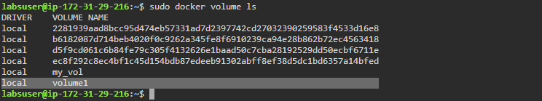

**Step 2:** Use the volume to create a replicated service

* Use the following command to create a replicated service using the *local volume:*

*sudo docker service create -d --replicas=4 --name replicated-service *

*--mount source=volume1,target=/app nginx:latest*



* Use the following command to list the replicated services:

*sudo docker service ps replicated-service*

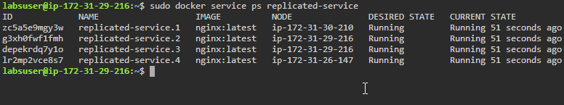

**Step 3:** Inspect worker nodes accessing the same volume for storage across cluster nodes

* Click on the **worker1** tab and navigate to the newly opened tab of worker1 node

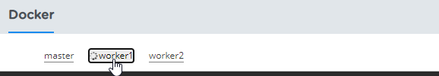

* Use the following command to list the local volumes on *worker1* node:

*sudo docker volume ls*

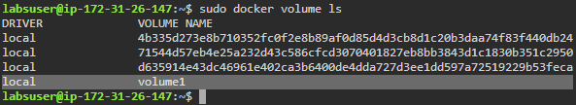

**Note:** Volume created on the **manager** node is used by the **worker1** node.

* Click on the **worker2** tab and navigate to the newly opened tab of worker2 node

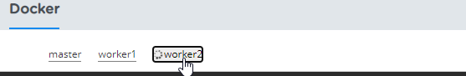

* Use the following command to list the local volumes on *worker2* node:

*sudo docker volume ls*

